**­MU BUS GPS Device Management Portal**

**A PROJECT REPORT**

***Submitted by***

**Aditya Pandya - 92110133032**

***In partial fulfillment for IWT (01CT0408) Project***

**Sem – 4th**

**Degree ENGINEERING**

***in***

**Information and Communication Technology Engineering**



**Faculty of Technology Studies**

**Marwadi University, Rajkot**



|  |  |
| --- | --- |
| **Contents** |  |
|  | **I** |
| **Abstract** | **II** |
| **List of Tables** | **III** |
| **List of Figures** | **IV** |
| 1. **Introduction** | **1** |
| 1.1. Document purpose | 1 |
| 1.2. Product scope | 1 |
| 1.3. Intended audience and document overview | 1 |
| 1.4. Definitions, acronyms and abbreviations | 2 |
| 1.5. Document conventions | 2 |
| 1.6. References and acknowledgments | 3 |
| 2. **Overall description** | **4** |
| 2.1. Product perspective | 4 |
| 2.2. Product functionality | 4 |
| 2.3. Users and characteristics | 4 |
| 2.4. Operating environment | 5 |
| 2.5. Design and implementation constraints | 5 |
| 2.6. User documentation | 5 |
| 2.7. Assumptions and dependencies | 5 |
| 3. **Specific requirements** | **6** |
| 3.1. External interface requirements | 6 |
| 3.2. Functional requirements | 6 |
| 3.3. Behaviour requirements | 7 |
| 4. **Other non-functional requirements** | **9** |
| 4.1. Performance requirements | 9 |
| 4.2. Safety and security requirements | 9 |
| 4.3. Software quality attributes | 9 |
| **Appendix A – Data Dictionary** | **10** |
| **Appendix B – Plagiarism Report** | **13** |
| **Appendix C – User Manual** | **15** |

# Abstract

**Problem Statement:**

When Any huge organisation like Marwadi University has big and complex Transportation system and lot of Students & faculties, employees are the beneficiary of the transportation system so here is come the big challenging task for transportation department to managing routes and the all the buses. Students are always waiting for the bus on the pick up Location. When sometimes students get late to rich at the pick up location they what is about might I missed my bus and all other thinks.and they call the bus driver and driver also ride the bus so driver can not pick the call. So this is the big problem for any big organisation.

**Solution statement:**

We are coming up with the solution of this problem and we called it “MU Bus” MU Bus is Student side Mobile App that can be useful for student. We are developing GPS Device and we will establish this GPS Device in the all the MU Buses and this device will communicate with Mobile app and student can watch live location of there bus.

Again. Managing the GPS devices also big challenging task for the transportation department. So We are also developing MU Bus Portal for the transportation department. So GPS Device can be easily manage by Transprotation head.

# List of Table

Table 1.Definition 2

Table 2.Abbreviation 2

# List of Figure

Figure 1 Use-case

Figure 2 ER Diagram

Figure 3 Activity Diagram

Figure 4 Block Diagram Hardware

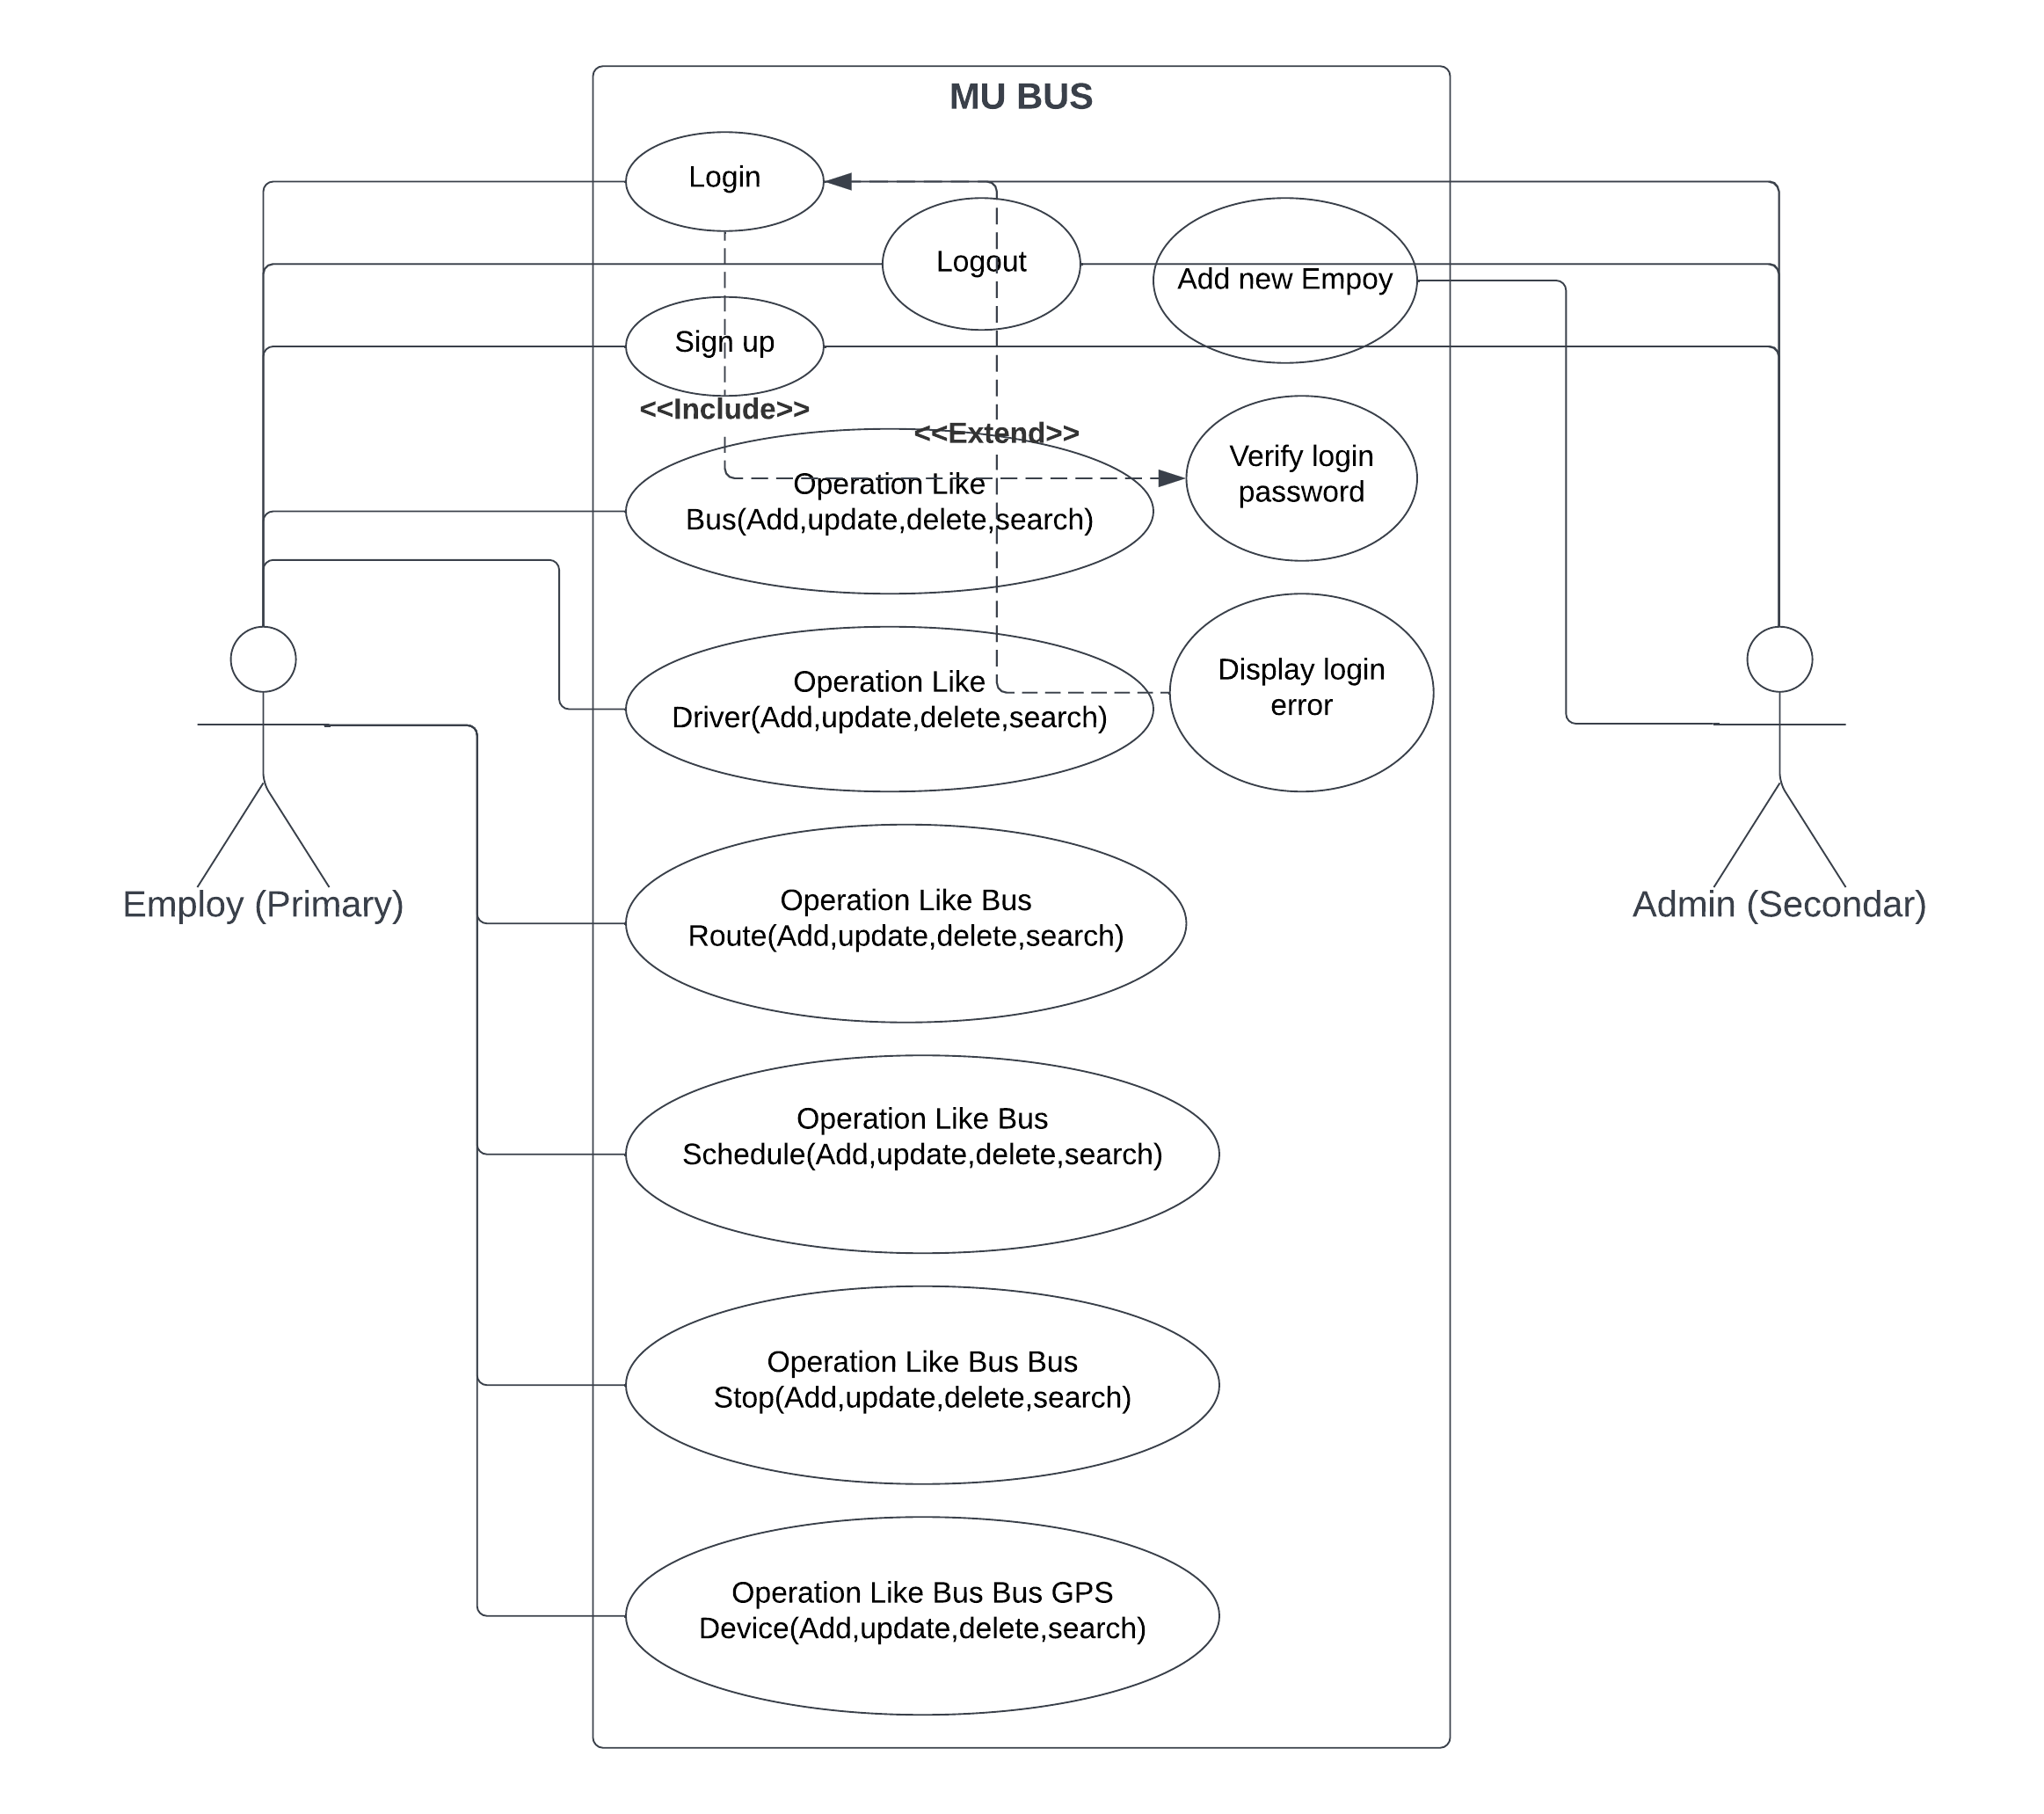

### Figure 1 Use Case

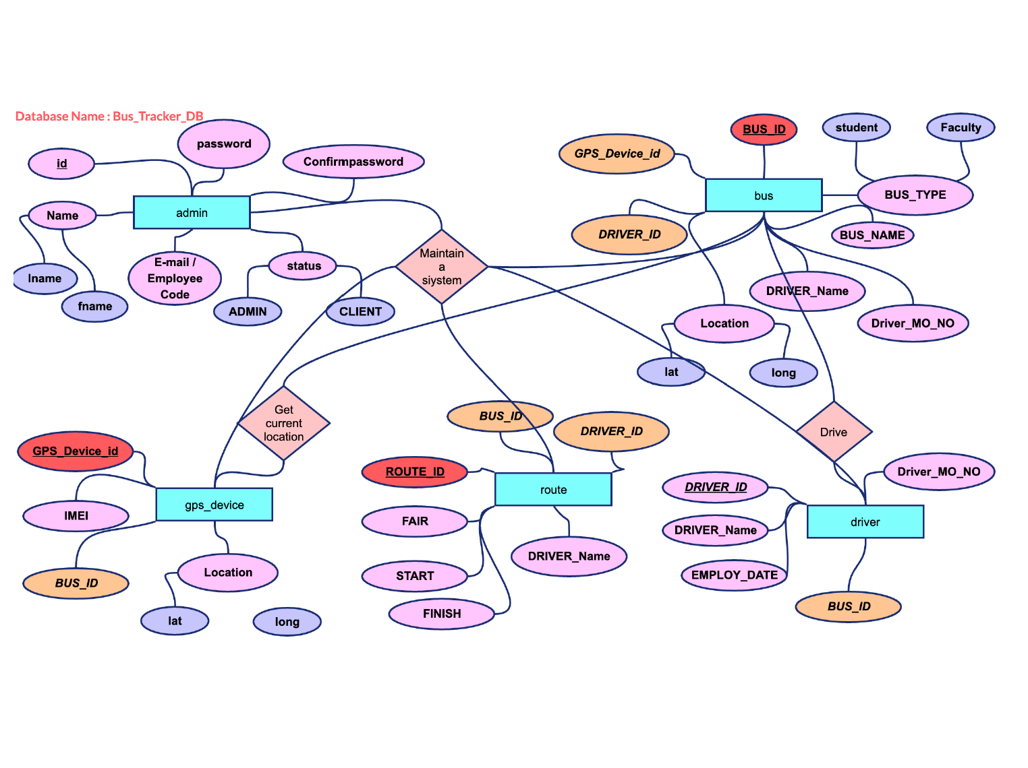

**Figure 2 ER Diagram**

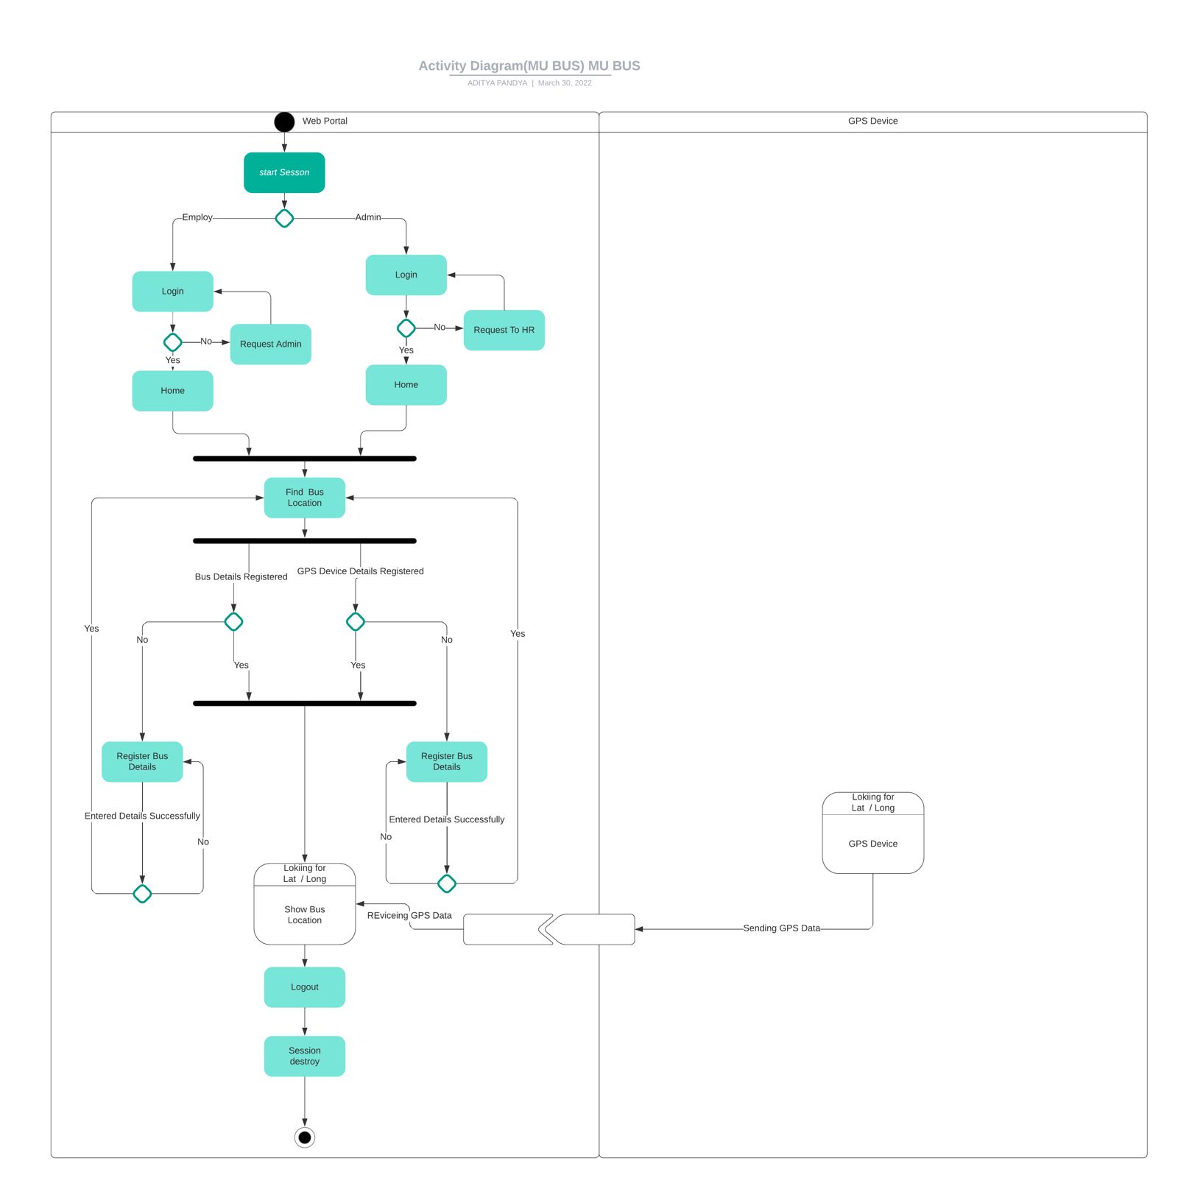

**Figure 4** Activity **Diagram**

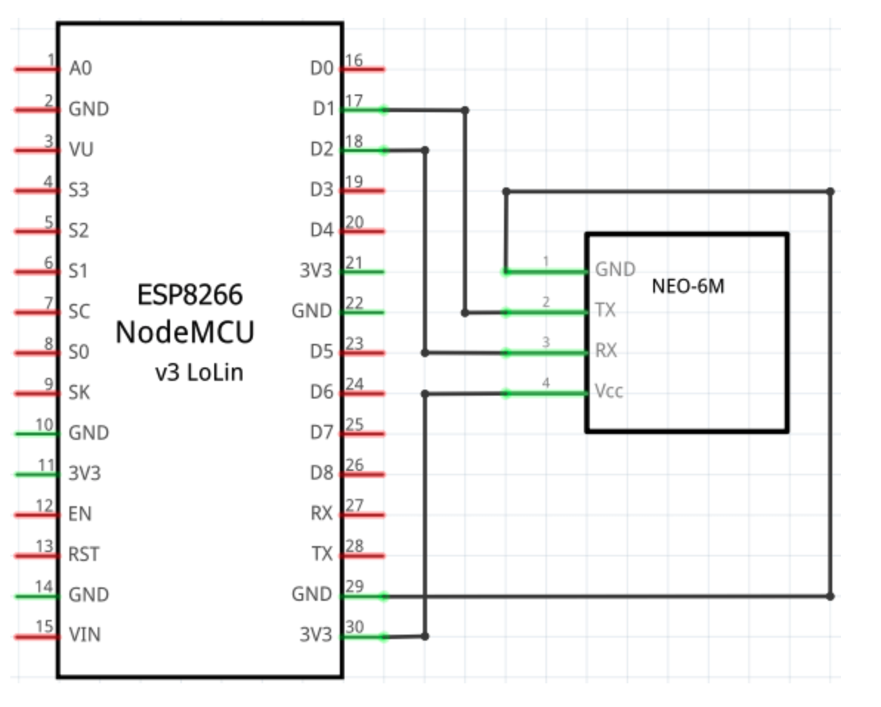

Block & PIN Diagram Hardware

# Introduction

## Document Purpose

This document is used for to understand the flow of the system.It described the system characteristics , flow of software , how to use the system.Document is mainly used for user to understand what about system do, what is the system used for and why this system being developed.

## Product Scope

This software will help to maintain the blood record. It is also maintain the blood request and approve the blood request. Application is helpful to maintain record of all customer and its payment details.It also maintain the donor details, donation details and donor’s health record details.Using this application, hospital can save their time and reduce the paper work.

## Intended Audience and Document Overview

This application is desktop application so this application is only run by admin.Only admin can use this application.This application mainly used for to maintain all record of blood bank.

This document will provide further information like functional requirements,behavioral requirements ,user interfaces ,constraints and assumption made for this system.

## Definitions, Acronyms and Abbreviations

### Table 1.Definitions

|  |  |
| --- | --- |
| Administrator | A person who responsible for maintain all over system. |
| Login | A process to get a access of any system. |
| Actor | An actor was object of any system like bank,school,hospital. |
| Database | Collection of data to store in any computer system. |
| Primary Key | Primary key identified uniquely record from table. |
| Table | Collection of record in relational database. |

|  |  |
| --- | --- |
| **Table 2.Abbreviation** UML | Unified Modeling Language |
| SQL | Structure Query Language |
| GB | Giga Byte |
| SRS | Software Requirements Specifications |
| PK | Primary Key |

.

## References

* https://[www.life4life.org.in/blood.php](http://www.life4life.org.in/blood.php)
* <http://nbtc.naco.gov.in/>
* Google.com
* Youtube.com

# Overall Description

## Product Perspective

This product will be help into hospitals to manage blood bank and can help for separate blood bank.This application provide management of donor details,manage donor health record, customer record, blood record,and stock record to maintain the blood.

## Product Functionality

In this application, admin first check the donor health details and verify donor for donate blood.Then if he/she is eligible for donate blood then admin add donor details like name,contact,email address,address,blood group etc.Admin can view the blood request and approve the request and add the customer’s record into customer table.Donor can donate blood and update stock record.After blood donation, add to blood record information like donor name, time at he/she donate blood,quantity and blood group into blood record.

## Users and Characteristics

### Main functionality from admin side :

1. Admin can add,update,delete Bus.
2. Admin can add,update,delete Route.
3. Admin can add,update,delete GPS Device details.
4. Admin add,update,delete Driver record.
5. Admin can view live Location of the Bus.
6. Admin can add,update,delete GPS Device details.

## Operating Environment Software Requirement :

Operating system : Mac OS

IDE : Visual studio Code & Arduino

Front-end : HTML,CSS ,Javascript

Back-end : phpmyAdmin

Database : MySQL

## Hardware Requirement :

Processor : Apple M1

RAM : 4GB RAM or more

Hard-disk : 20GB or more

## GPS Device Hardware Requirement :

Processor : ESP12 E Chip

RAM : 1024 KB RAM

Code Memory : 4MB

## Design and Implementation Constraints

* Other user can not interact with the system.

## User Documentation

In this application any user can not interact with the system.This is web application ,but this is limited for particular university and College Only admin can used this application.Admin can changes in system.All functionality used by admin.We can add user for give access of system if admin is not present in emergency.

## Assumptions and Dependencies

* User must be trained for basic computer functionality and have knowledge of computer.
* User must have a knowledge of English.
* Product does required back-end database MYSql server for storing data.

# Specific Requirements

## External Interface Requirements

### User Interfaces

User of the system provide for user authentication.That is provide graphical user interface.User is help for to verify the user is valid or not by username or password.

### Hardware Interfaces

In this hardware must be used for run this application like processor, hard-disk for storing the data and needed file for this application.No external hardware needed in this application.

### Software Interfaces

Following are software used for blood bank management system :

* Operating system : We are used operating system for run our application and best support for run this application.
* Database : Database is used mainly for to store data of all over the data of application.In this system we save the donor health record, customer record, stock record etc.
* Visual studio Code 2010 : This is application is used C# .Net language so visual studio is best supporter for this language.

### Communications Interfaces

This application is based on Web application.

## Functional Requirements

Admin:

1. Admin can login
2. Admin can register new Employee
3. Admin can monitor all the data like…….

* How many buses are registered
* How many drivers are registered
* How many routes are registered
* How many stops are registered
* How many GPS Device are Active or deactive
* Where is current location of the Buses (in Map view)

1. Admin can delete Employee
2. Admin can view Employee Log
3. Admin can view Employee Data

Employee:

1. Employee can register new Bus
2. Employee can register new Driver
3. Employee can register new route
4. Employee can register new GPS Device
5. Employee can view Data like……

* How many buses are registered
* How many drivers are registered
* How many routes are registered
* How many stops are registered
* How many GPS Device are Active or deactive

1. Where is current location of the Buses (in Map view)
2. Employee can edit bus details
3. Employee can edit driver details
4. Employee can edit route details

10.Employee can edit GPS Device details

11.Employee can delete bus

12.Employee can delete driver

13.Employee can delete route

14.Employee can delete GPS Device

## Behaviour Requirements

### Use Case View



**Figure 3.1 Use-case Diagram**

Given below is the description of above picture of use-case diagram :

### Admin :

* Admin can add,update,delete Bus.
* Admin can add,update,delete Route.
* Admin can add,update,delete GPS Device details.
* Admin add,update,delete Driver record.
* Admin can view live Location of the Bus.
* Admin can add,update,delete GPS Device details.

# Other Non-functional Requirements

## Performance Requirements

Following Non-functional requirement will be there used:

* Secure access to login unauthorized person.
* 24 X 7 Available
* Better component used for design the system.

## Safety and Security Requirements

This application provide login page for entering in the system.For security concern.If admin login successfully, then after all rights are given to admin.

Password is storying with AES 16 bit encryption algorithm.

## Software Quality Attributes

In this application used Sql server 2008 for storing data of system.There are many higher version available for Sql server,but we more prefer this version because of higher version take consumption CPU power and computability and slower the performance of the system.

# Appendix A – Data Dictionary

**Table 1. admin record**

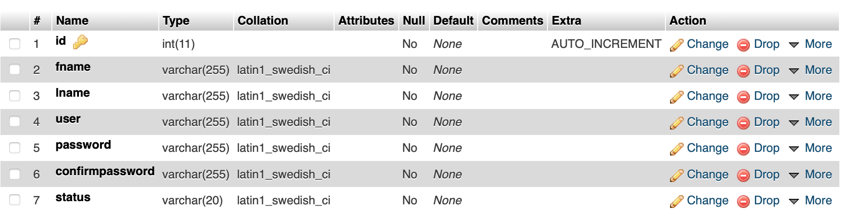

**Table 2 bus_details**

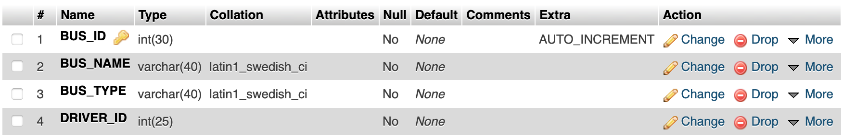

**Table 3. driver**

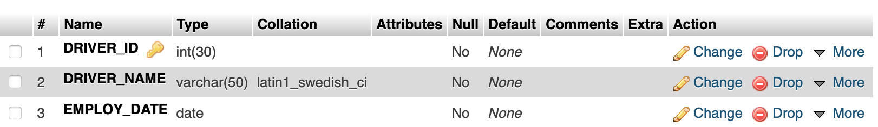

**Table 4. route**

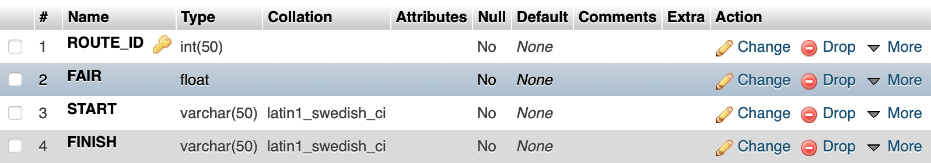

**Table 5. schedule**

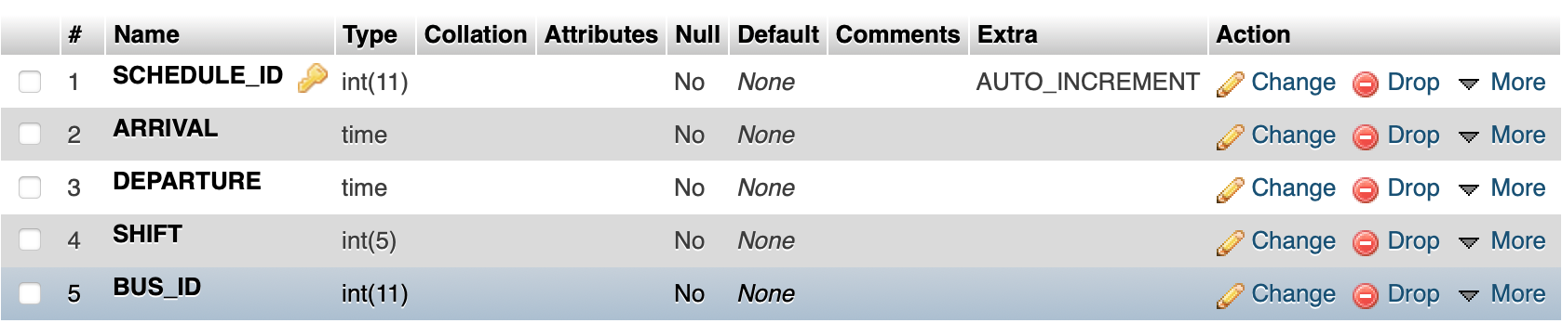

**Table 8. Stop**

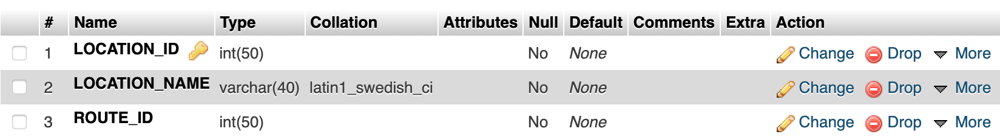

**Table 8. GPS Device**

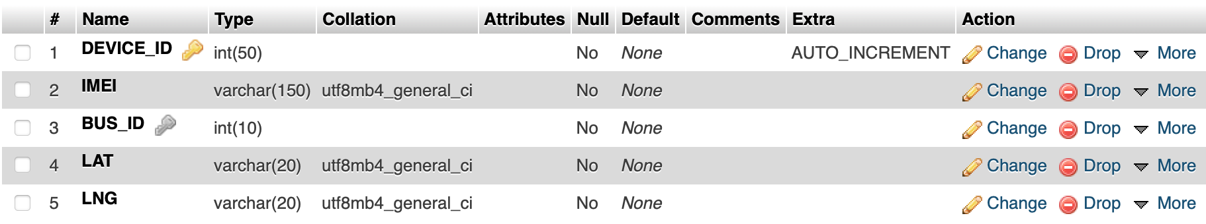

# Appendix B – Plagiarism Report



PLAGIARISMSCAN REPORT

|  |  |  |  |
| --- | --- | --- | --- |
| Words | 976 | Date | May 06,2022 |
| Characters | 6725 | Exclude Url |  |

|  |  |  |  |
| --- | --- | --- | --- |
| 0%  Plagiarism | 100%  Unique | 0  Plagiarized Sentences | 30  Unique Sentences |

Content Checked For Plagiarism

Sources Similarity

# Appendix C – User Manual

# & Screens

Screen 1: Login

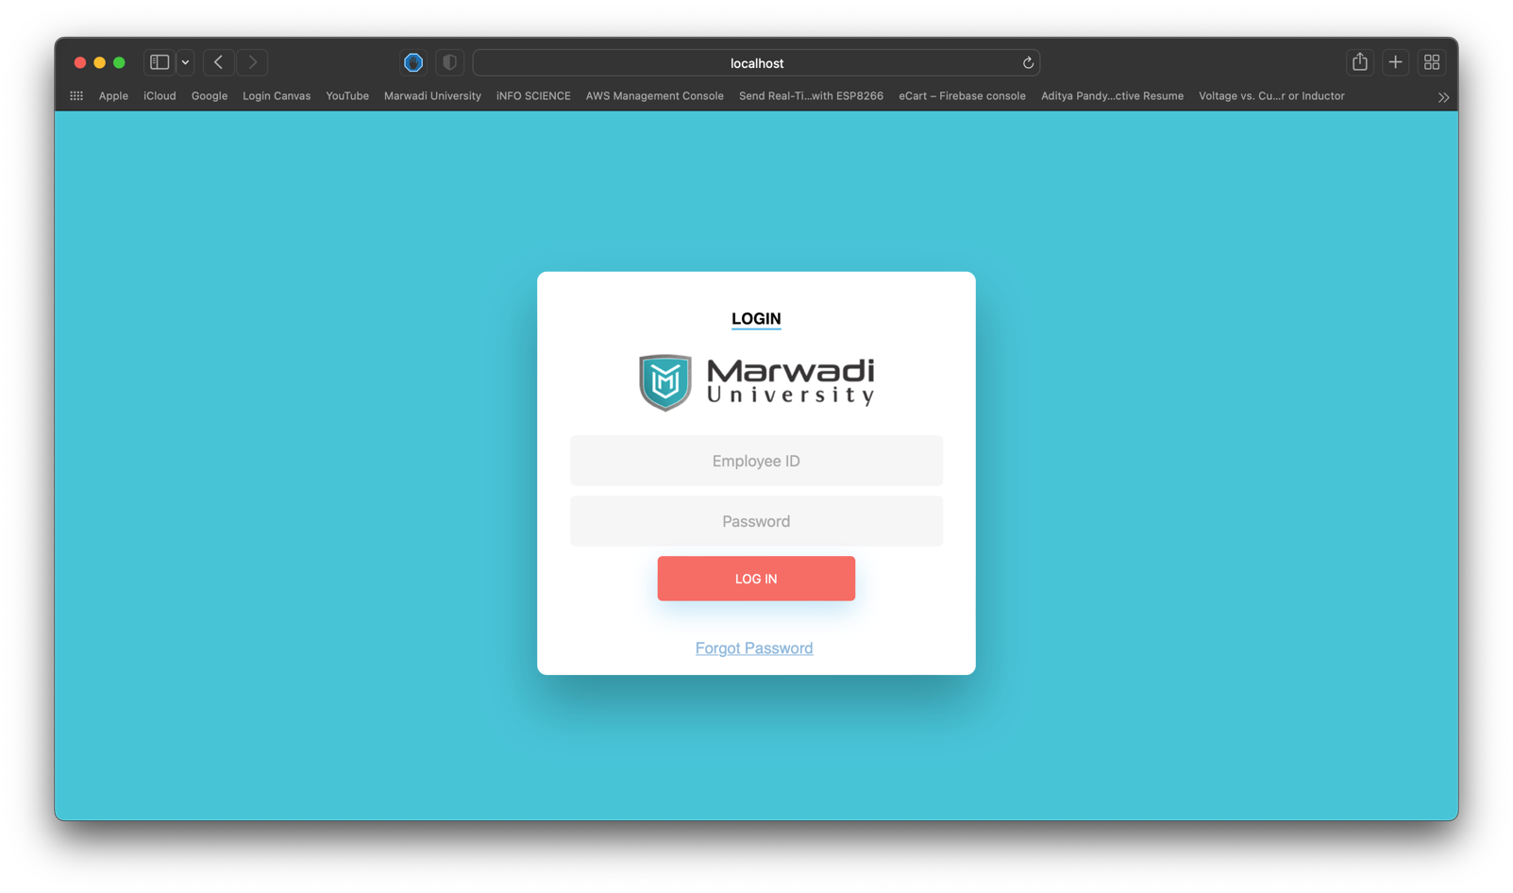

Screen 2: Home

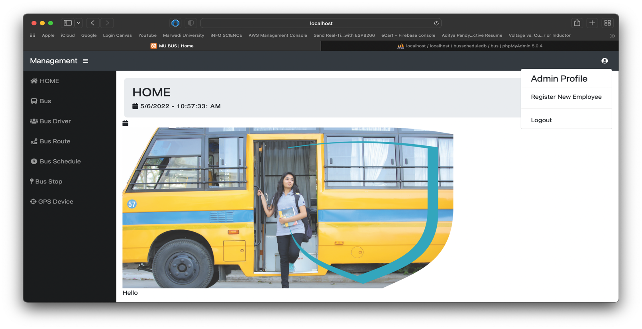

Screen 3. : Bus

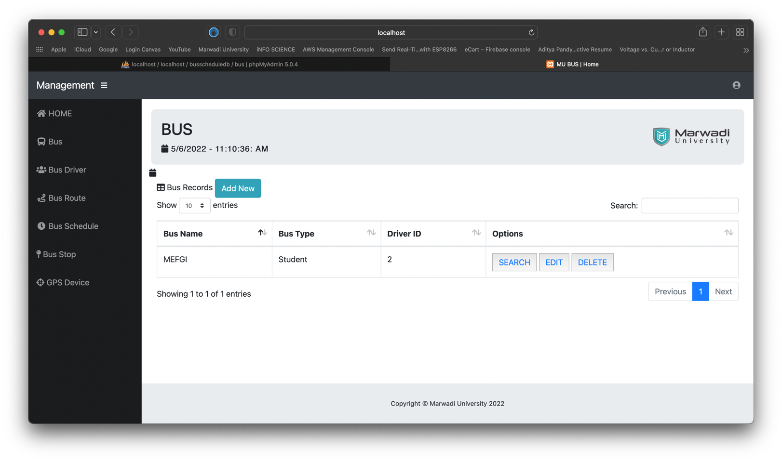

Screen 4 : Add Bus

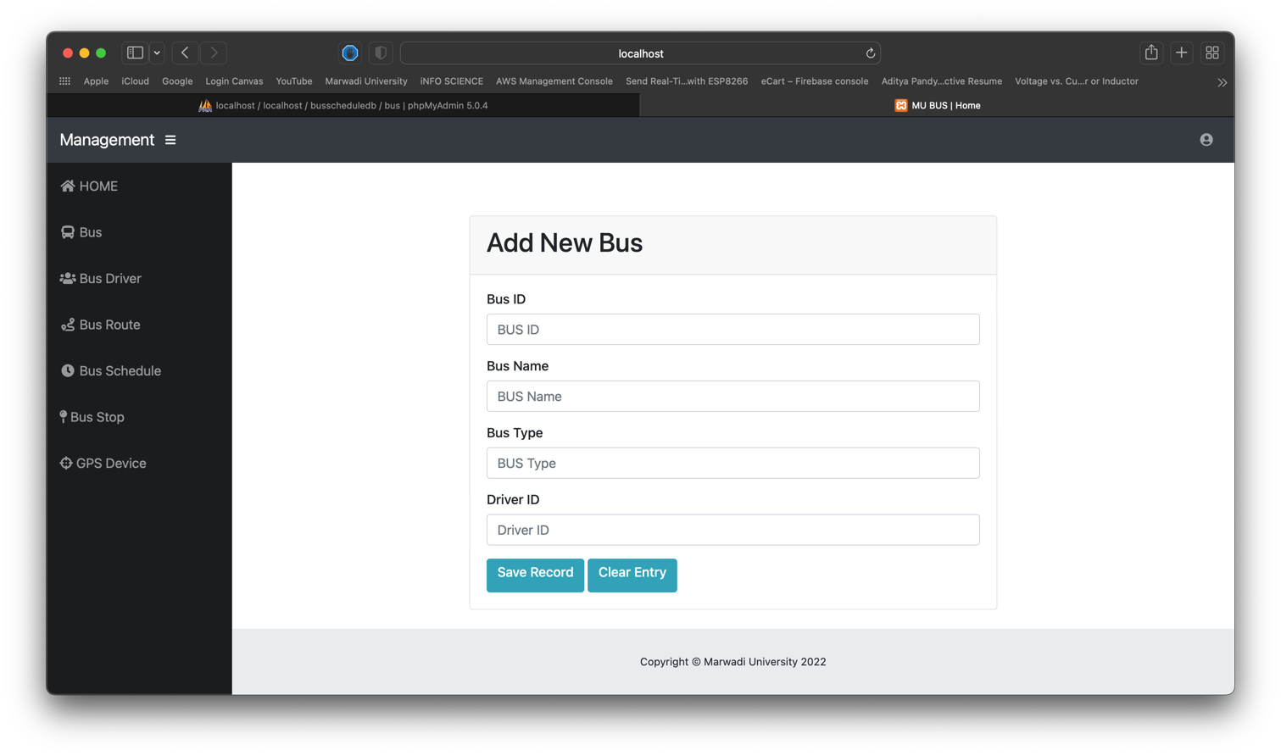

Screen 5 : Driver

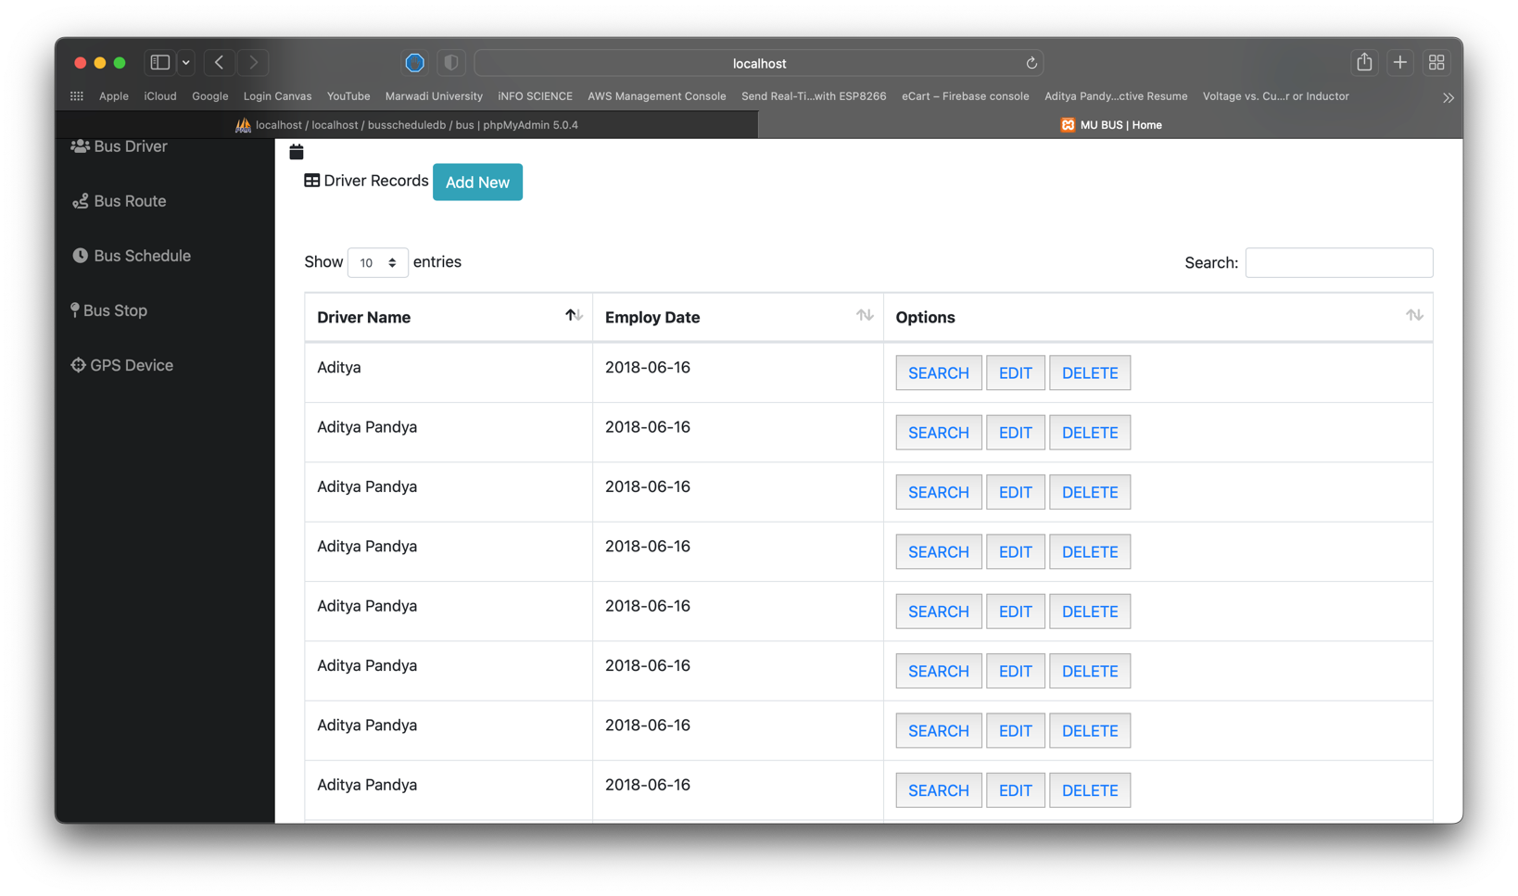

Screen 6 : Add Driver

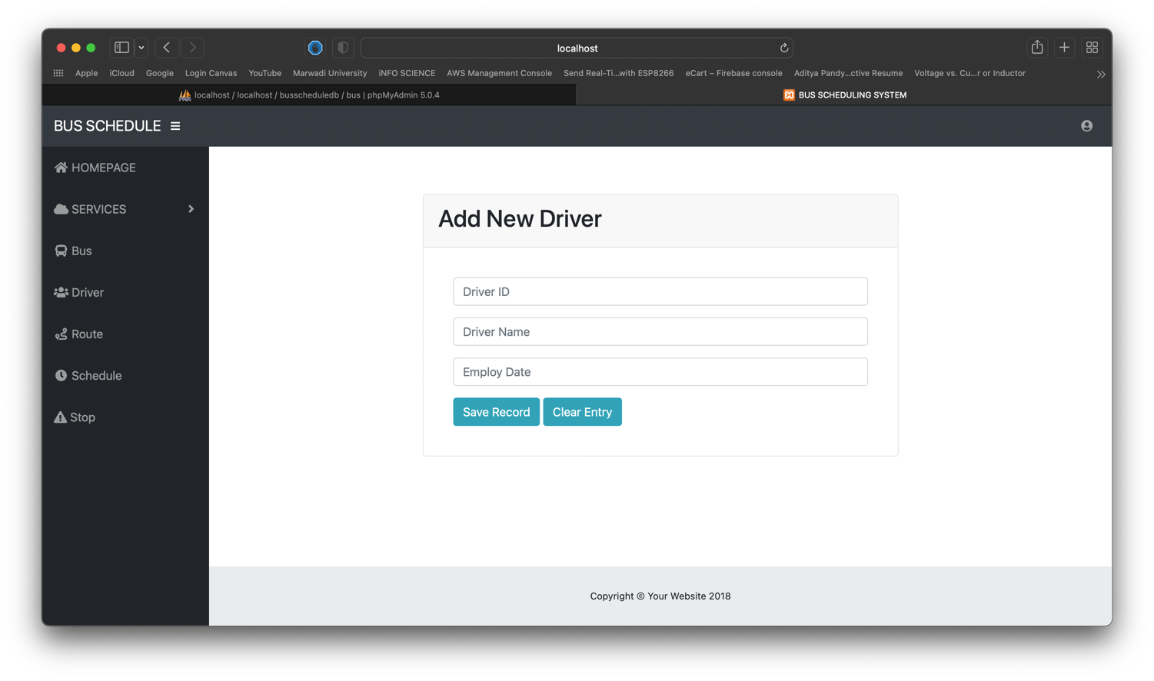

Screen 7 : Pagenation

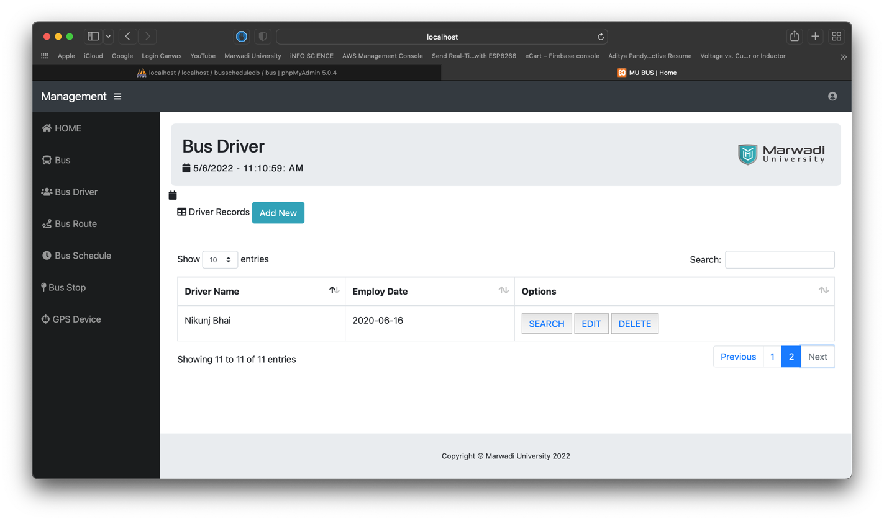

Screen 7 : Schedule

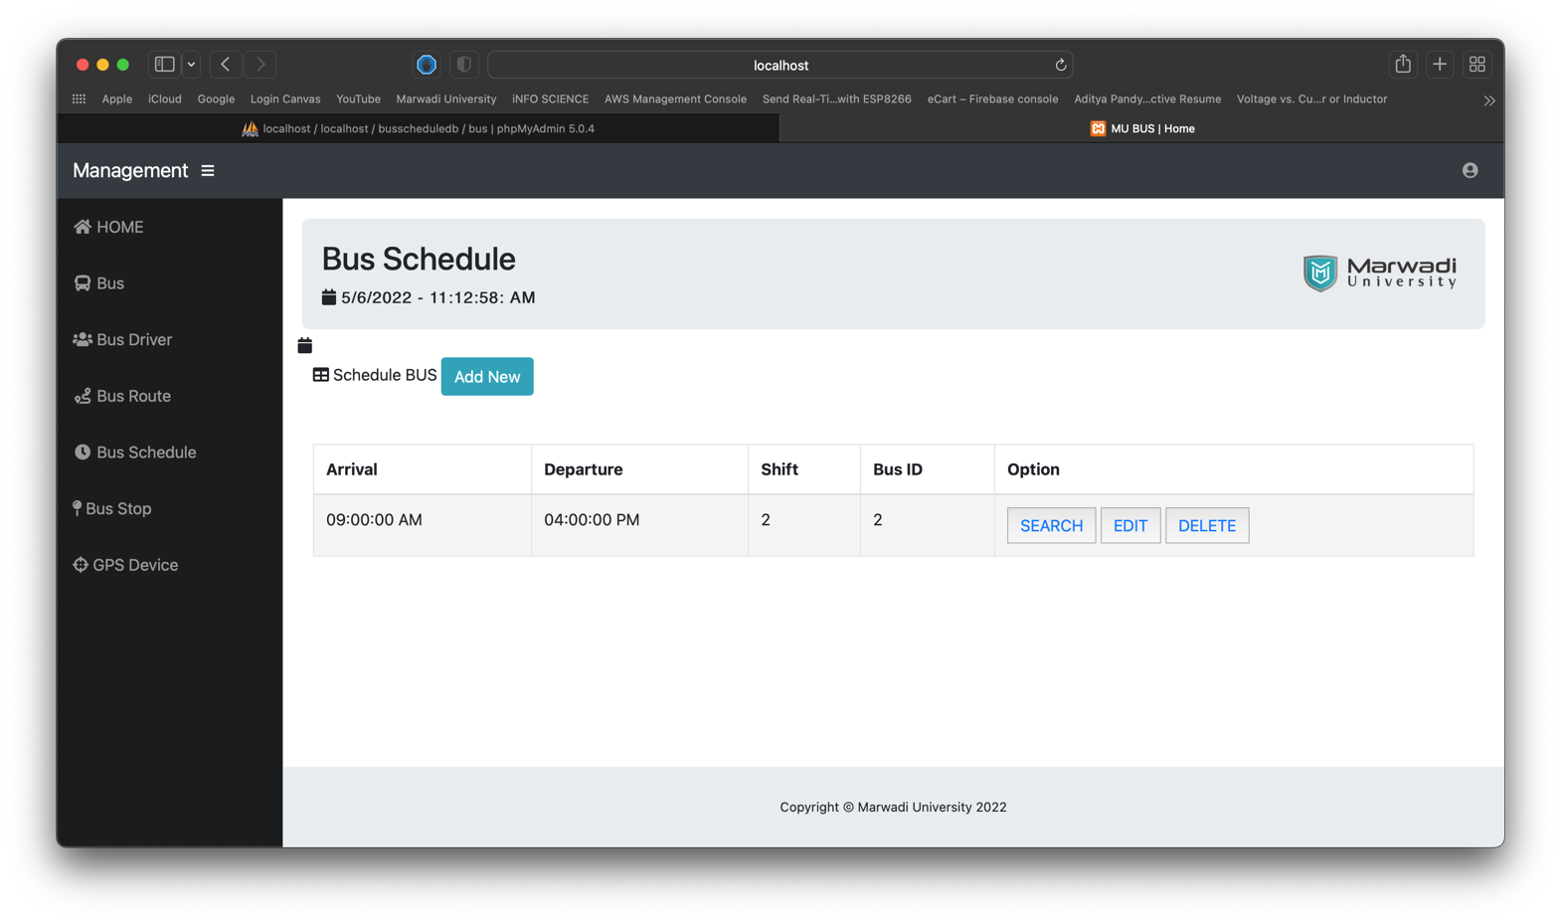

Screen 7 : Schedule